Below are the steps to update the column type and add new column in AspNetUser table.

1. Define properly in ApplicationUser class.  
   D:\Kiran Bala\Projects\USGAI\Phase2\usgai.core\Models

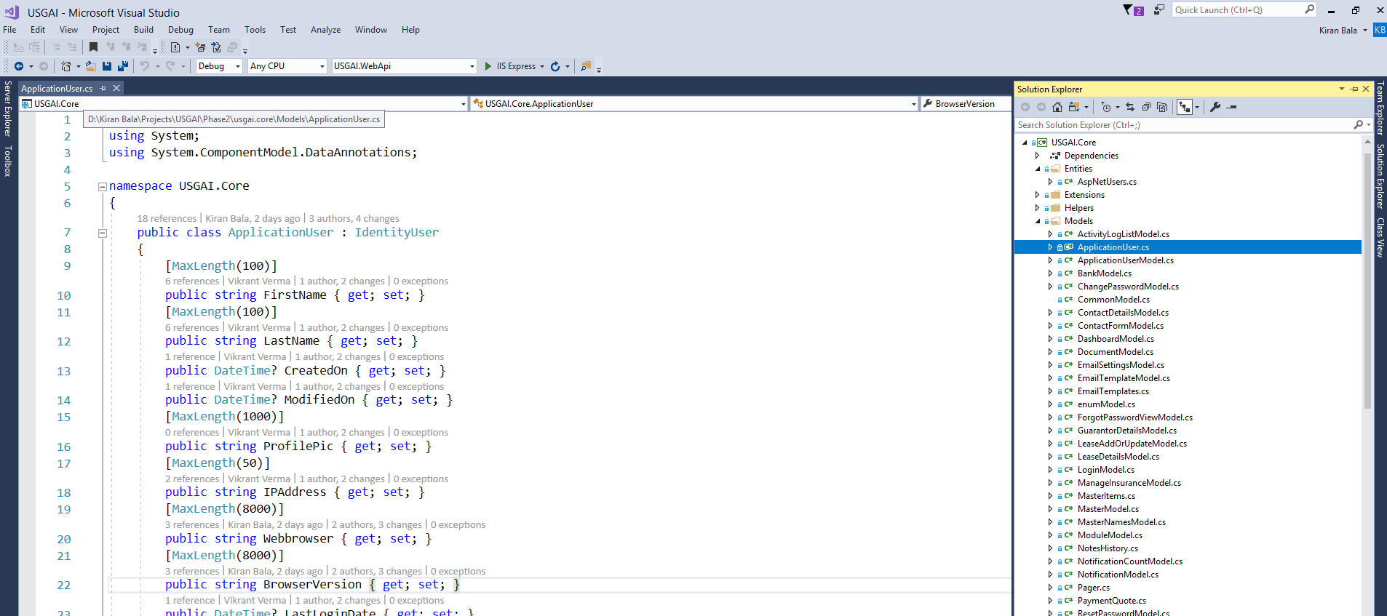

1. Open Package Manager Console  
   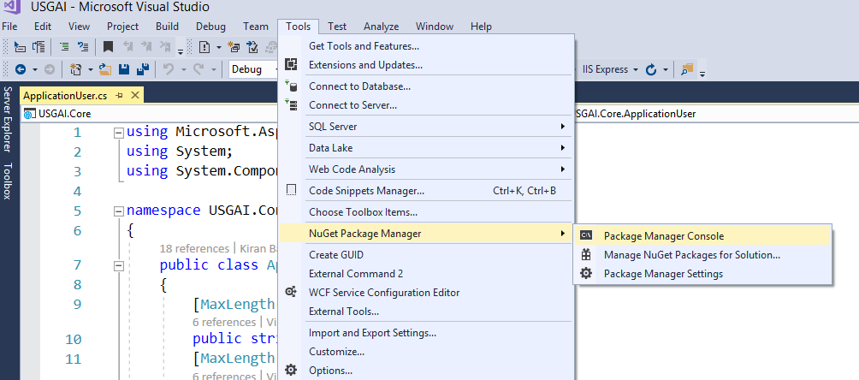
2. Comment the Test server database connection string in startup file (WebApi project).  
   Otherwise got the build error.  
     
   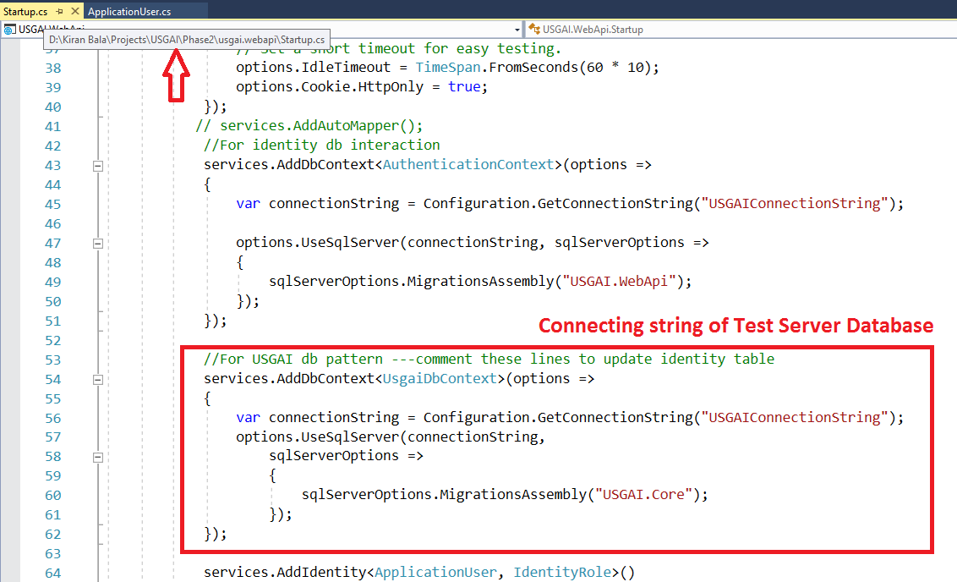
3. Unload the Portal Project.  
   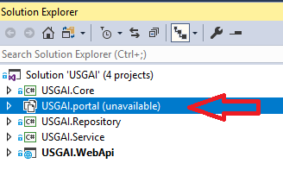
4. If face below error then change the name of Initial as   
   --- PM> Add-Migration Initial1  
     
   
5. After running Add Migration run update database command. This will update the AspNetUser table.  
   ---- PM> update-database
6. Migration classes will be created here.  
     
   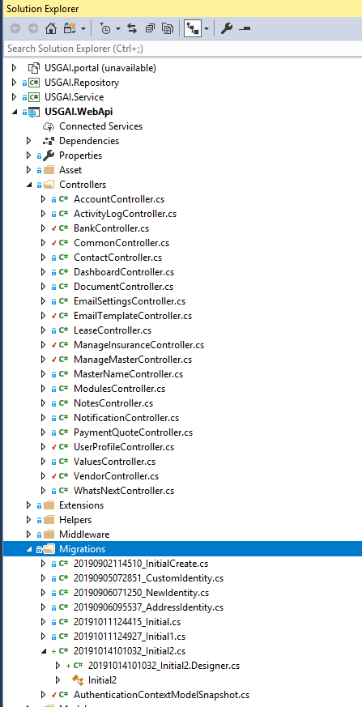
7. Migration table –save history of Migrations – upload the records of table.  
     
   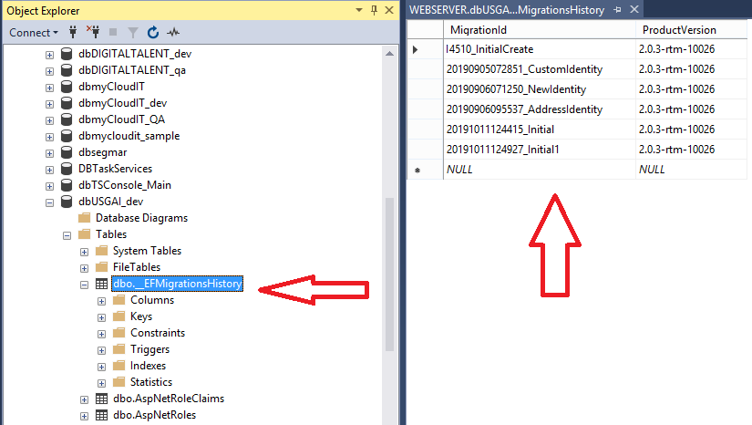
8. Successfully running commands  
   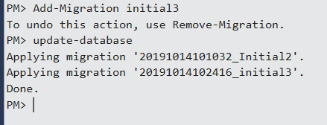
9. Uncomment the database string in startup file which was commented above in #3.
10. Reload **Portal** project –done in #4.

services.AddDbContext<AuthenticationContext>(options =>

options.UseSqlServer(Configuration.GetConnectionString("AllCoreConnectionString")));